**UCS 2312 Data Structures Lab**

**Assignment 8: Binary Heap And Its Applications**

**Date of Assignment: 07.11.2023**

priorityQueueADT consists of integer element. Implement the following methods

* void insert(struct priorityQueueADT *P, int x) – Insertion new item into priority queue using Max Heap property
* int delete(struct priorityQueueADT *P) – Will remove the root of binary heap
* void display(struct priorityQueueADT *P) – Will display the contents pf Priority Queue

1. Demonstrate ADT with the following testcase

insert(p,14);

insert(p,16);

insert(p,22);

insert(p,11);

insert(p,9);

insert(p,18);

insert(p,10);

insert(p,7);

insert(p,4);

insert(p,1);

2. Write an application to design a priority queue using max binary heap. An item in the priority queue consists of employee id and salary amount. The queue supports two operations, namely, insertion and deletion.

Test the application with the following

insert(p,(‘A’,15000));

insert(p,(’K’,12000));

insert(p,(‘R’,4000));

insert(p,(‘T’,3500));

insert(p,(‘L’,4600));

insert(p,(‘P’,6000));

insert(p,(‘Y’,8600));

Output:

Employees are removed in the following order

(‘A’,15000), (’K’,12000), (‘Y’,8600), (‘P’,6000), (‘L’,4600), (‘R’,4000), (‘T’,3500),

**Data Structure – Binary Heap:**

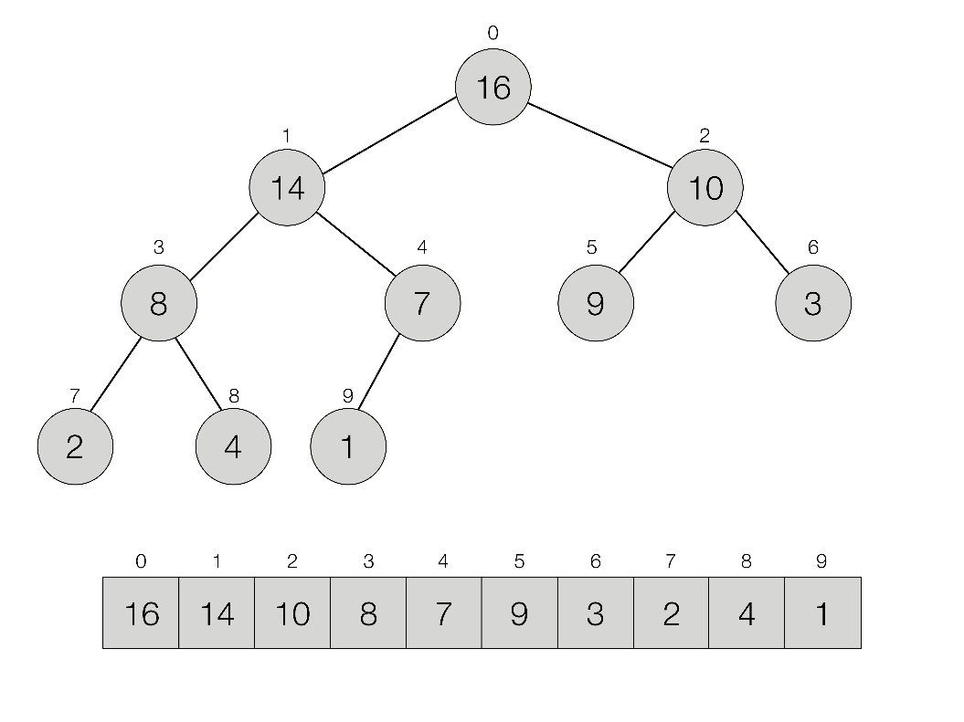

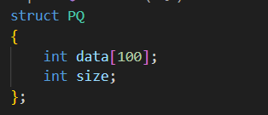

**Algorithm –**

**Algorithm: Insertion new item into priority queue using Max Heap property**

Input – Pointer to Priority Queue, data to be added to Priority Queue

Output – void

1. i=++P->size
2. while (P->data[i/2]<x)

P->data[i]=P->data[i/2]

i/=2

1. P->data[i]=x

**Algorithm: Will remove the root of binary heap**

Input – Pointer to Priority Queue

Output – int

1. If(P->size<1)

return 930

1. max=P->data[1]
2. last=P-data[P->size--]
3. i=1
4. while((i*2)<=P->size))

child=i*2

if(P->data[child+1]>P->data[child])

child++

if(last<P->data[child])

P->data[i]=P->data[child]

else

break

i=child

1. P->data[i]=last
2. Return max

**Algorithm: Will display the contents pf Priority Queue**

Input – Pointer to Priority Queue

Output – void

1. i=1
2. while(i<=P->size)

print P->data[i]

i++

**MaxHeap.h code:**

#include<stdio.h>

#include<stdlib.h>

#include"AVLtree.h"

void main()

{

struct tree* t=NULL;

int choice=100;

int el;

while(choice!=4)

{

printf("\n\n1.Insert\n2.Print\n3.Find Parent\n4.Exit\nChoice = ");

scanf("%d",&choice);

switch(choice)struct PQ

{

int data[100];

int size;

};

void create(struct PQ* P)

{

P->size=0;

P->data[0]=930;

}

void insert(struct PQ* P,int x)

{

int i;

for(i=++P->size;P->data[i/2]<x;i/=2)

{

P->data[i]=P->data[i/2];

}

P->data[i]=x;

}

int deleteMin(struct PQ* P)

{

if(P->size<1)

{

printf("Queue Empty");

return 930;

}

int i,child;

int max=P->data[1];

int last=P->data[P->size--];

for(i=1;(i*2)<=P->size;i=child)

{

child=i*2;

if(P->data[child+1]>P->data[child])

{

child++;

}

if(last<P->data[child])

{

P->data[i]=P->data[child];

}

else

break;

}

P->data[i]=last;

return max;

}

void print(struct PQ* P)

{

for (int i=1;i<=P->size;i++)

printf ("(%d) ",P->data[i]);

}

{

case 1:

printf("Enter the element: ");

scanf("%d",&el);

t=insert(t,el);

break;

case 2:

hierarchical(t,0);

printf("\n\n");

break;

case 3:

printf("Enter the element: ");

scanf("%d",&el);

struct tree *parent=findParent(t,el);

if(parent!=NULL)

printf("Parent = %d",parent->data);

else

printf("Element Not Found");

break;

case 4:

exit(0);

break;

}

}

}

**MaxHeap.c code:**

#include<stdio.h>

#include<stdlib.h>

#include"MaxHeap.h"

void main()

{

struct PQ* P=(struct PQ*)malloc(sizeof(struct PQ));

int choice=1;

int el;

create(P);

while(choice)

{

printf("\n\n1.Insert\n2.Delete Maximum\n3.Display\n4.Exit\nChoice : ");

scanf("%d",&choice);

switch(choice)

{

case 1:

printf("Enter the element: ");

scanf("%d",&el);

insert(P,el);

break;

case 2:

el=deleteMin(P);

if(el!=930)

printf("Max Element = %d",el);

break;

case 3:

printf("Elements : ");

print(P);

case 4:

exit(0);

break;

default:

printf("Invalid Choice");

}

}

}

**Output Screen:**

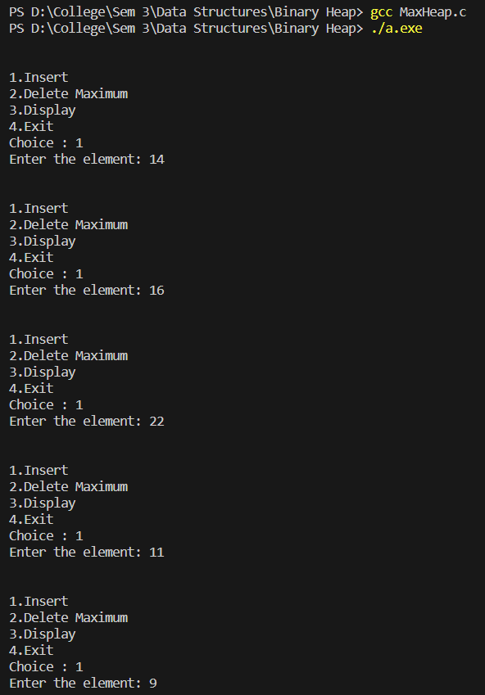

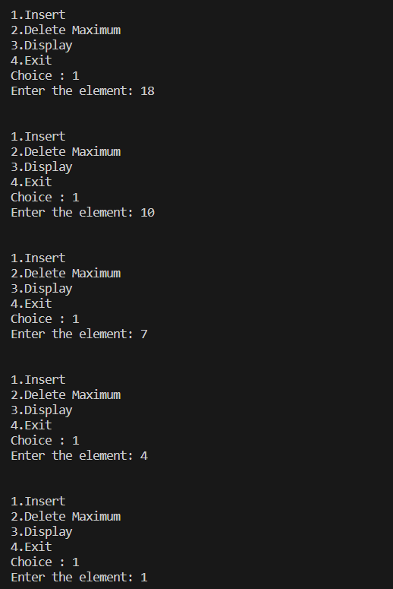

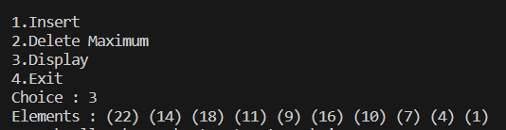

**Write an application to design a priority queue using max binary heap. An item in the priority queue consists of employee id and salary amount. The queue supports two operations, namely, insertion and deletion.**

**PriorityQueue.h code:**

#include <stdio.h>

struct emp

{

char id;

int salary;

};

struct pq

{

struct emp el[100];

int size;

};

void init(struct pq*p)

{

p->size=0;

p->el[0].id = 'Z';

p->el[0].salary = 10000000;

}

void print (struct pq*p)

{

for (int i=1;i<=p->size;i++)

printf ("(%c,%d)\t", p->el[i].id, p->el[i].salary);

}

void insert (struct pq*p, char id, int sal)

{

int i;

for (i=++p->size;p->el[i/2].salary<sal;i/=2)

{

p->el[i].id = p->el[i/2].id;

p->el[i].salary = p->el[i/2].salary;

}

p->el[i].id = id;

p->el[i].salary = sal;

}

struct emp deletemax (struct pq*p)

{

int i,child;

struct emp maxelt = p->el[1];

struct emp lastelt = p->el[p->size--];

for (i=1;(i*2)<=p->size;i=child)

{

child = i*2;

if (p->el[child+1].salary>p->el[child].salary)

child++;

if (lastelt.salary < p->el[child].salary)

p->el[i] = p->el[child];

else

break;

}

p->el[i] = lastelt;

return maxelt;

}

**PriorityQueue.c code:**

#include <stdio.h>

#include <stdlib.h>

#include "priorityQ.h"

void main ()

{

struct pq*p = (struct pq*)malloc(sizeof(struct pq));

init (p);

int d, ch=-1; char x;

struct emp e;

while (ch!=0)

{

printf ("\nMENU:\n1 - Insert\n2 - Delete maximum element\n3 - Print\n0 - Exit\nEnter your choice: ");

scanf ("%d", &ch);

scanf ("%c", &x);

switch (ch)

{

case 1:

{

printf ("Enter element to insert: ");

scanf ("%c", &e.id);

scanf ("%c", &x);

scanf ("%d", &e.salary);

insert (p,e.id,e.salary);

break;

}

case 2:

{

e = deletemax (p);

printf ("\n(%c,%d) is deleted.\n", e.id,e.salary);

break;

}

case 3:

{

print (p);

break;

}

case 0:

{

printf ("Quitting ...\n");

break;

}

default:

printf ("\nInvalid choice. Enter again.\n");

}

}

}

**Output Screen:**

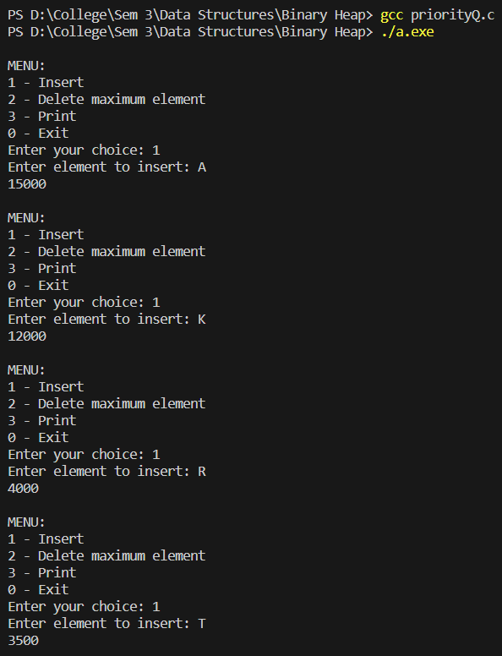

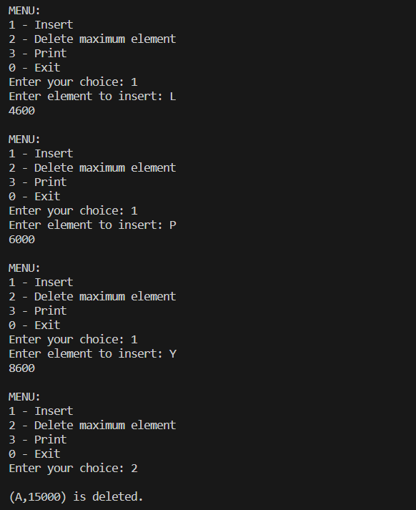

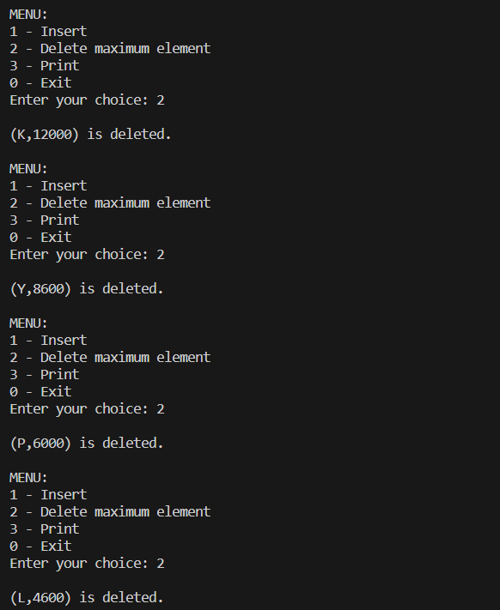

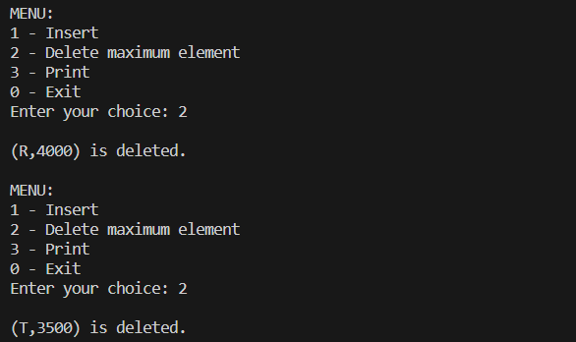

**Learning Outcome:**

